Kafka Connect:
Download Code: https://courses.datacumulus.com/kafka-connect-09a
Why Kafka connect and Stream:
- For common kafka usage:
Source => Kafka Producer API
Kafka => Kafka Consumer, Producer API
Kafka => Sink Consumer
Kafka => App Consumer

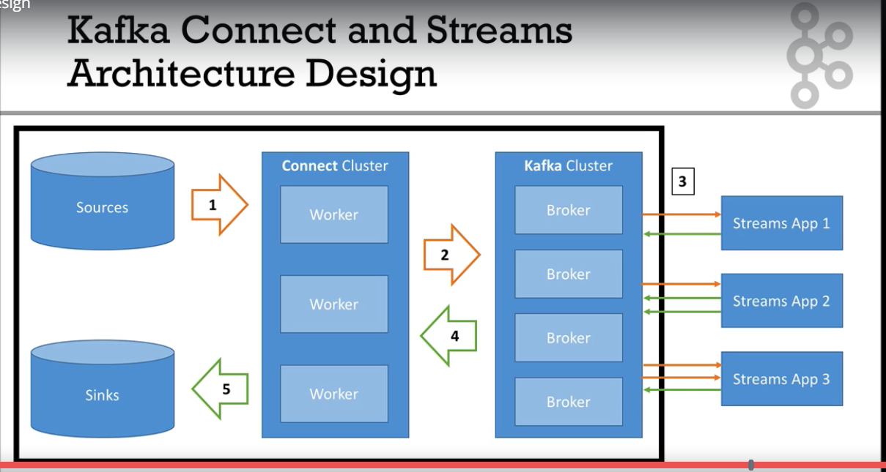

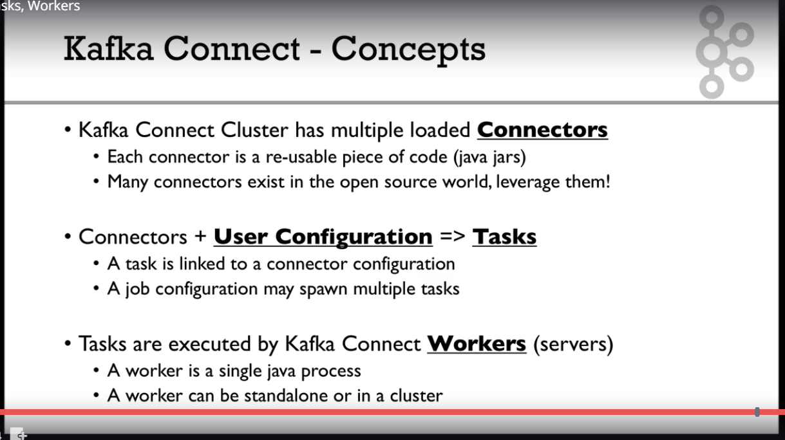
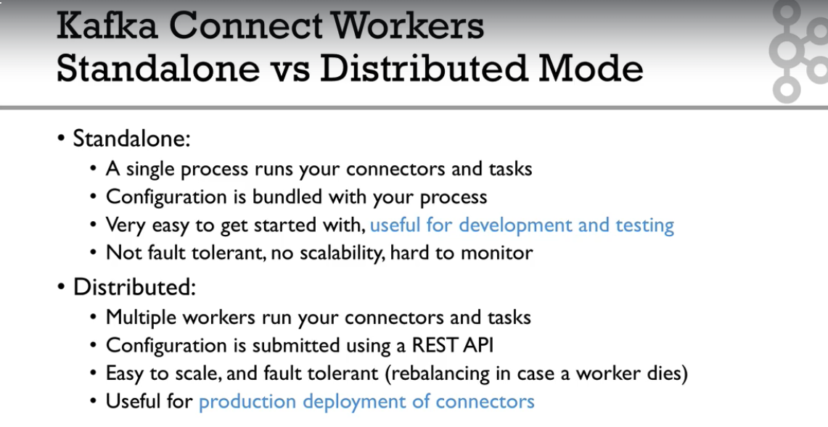

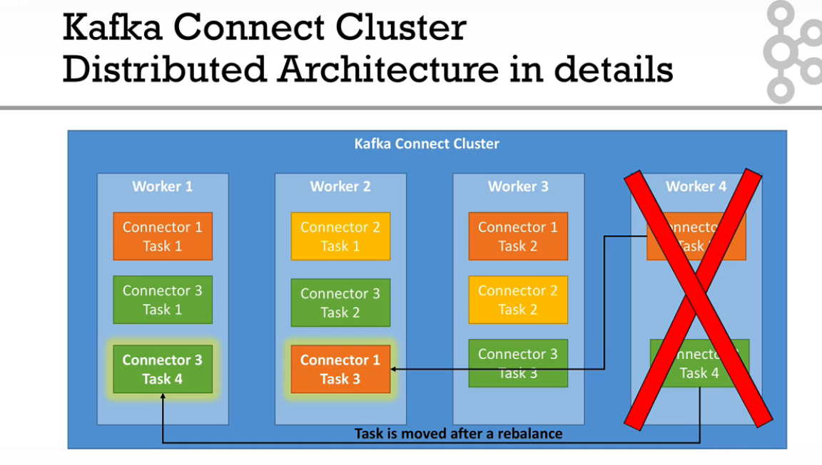
If you use Docker, then it will all go fine, and having Kafka Connect Cluster running on your machine will be very easy. See you in the next lectures!
Disclaimer: Docker has given me the authorisation to use some of their YouTube videos, and they are great. Hope you enjoy them!

Docker Installation:
Cmd : docker –version
Cmd : docker-compose –version
Cmd : docker run hello-world

